Rectangle of perimeter L m. Find in terms of L:

[a] The maximum area.

l

w

2w + 2l = L → l = $\frac{L – 2w}{2}$

A = lw = ($\frac{L – 2w}{2}$)w

[b] The dimensions.

A’ = $\frac{–4x + y}{2}$ → A’ = 0 → w = $\frac{L}{4}$

l = $\frac{L – 2(\frac{L}{4})}{2}$ = $\frac{L}{2}$ x $\frac{1}{2}$ = $\frac{L}{4}$

**A triangle has one side twice as long as the other, the third being replaced with a sufficiently long straight wall.**

**[a] Determine the maximum area, in terms of L. You don’t necessarily have to use calculus techniques but be sure to state your reasoning.**

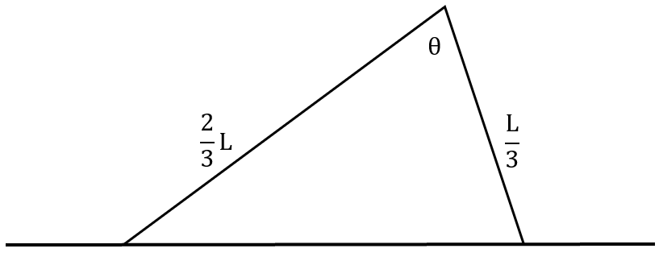

Let ‘A’ represent area.

A = $\frac{1}{2}$ ($\frac{2}{3}L$)($\frac{L}{3}$)sinθ = $\frac{2L^{2}}{18}$ sinθ = $\frac{L^{2}}{9}$ sinθ

$\frac{dA}{dθ}$ = $\frac{L^{2}}{9}$ cosθ → A’ = 0 → θ = $\frac{π}{2}$ (0<θ<π)

A = $\frac{L^{2}}{9}$ sin($\frac{π}{2}$) = $\frac{L^{2}}{9}$

**[b] Determine what would happen if the sides had no restrictions. Use calculus.**

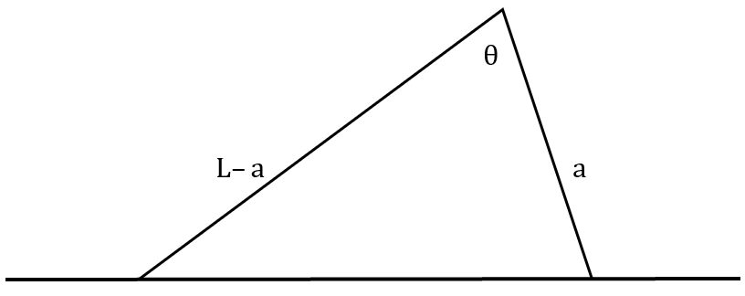

Let ‘A’ represent area.

A = $\frac{1}{2}$ (L–a)(a)sinθ = $\frac{La–a^{2}}{2}$ sinθ

$\frac{dA}{dθ}$ = $\frac{La – a^{2}}{2}$ cosθ → A’ = 0 → θ = $\frac{π}{2}$ (0<θ<π)

A = $\frac{La – a^{2}}{2}$ sin($\frac{π}{2}$) = $\frac{La – a^{2}}{2}$

$\frac{dA}{da}$ = $\frac{–2a + L}{2}$ → A’ = 0 → a =

A = (L–a)(a) = (L – )() = ()2 = x =